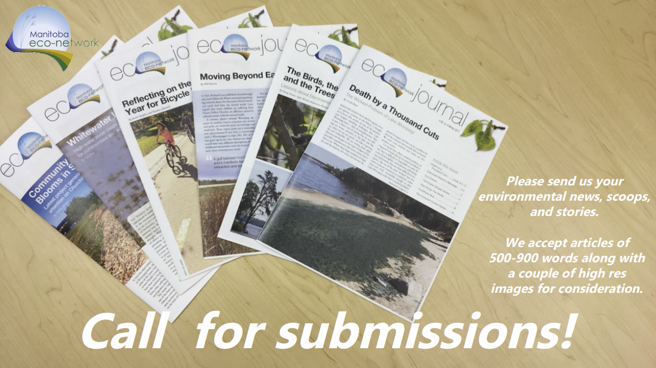
We're hard at work putting the final touches on the Spring edition of the Eco-Journal, and it's already time to start looking forward to our Summer edition.

What new projects, programs, and plans are you launching when the weather finally starts to warm again? We'd love to hear all about it!

We accept articles of 500-1100 words (approx.) along with a couple high res photos for consideration. Please send us your environmental news, scoops, and stories by May 1, 2018.

Contact editor@mbeconetwork.org for more info and to submit.

If you have any events taking place from June to September that you would like to submit to our event listings, or if you would like to place an ad in the Eco-Journal, you can do that here: info@mbecotnetwork.org

